Adding attachments to messages in CHIP
If you do not have this permission please contact the CHIP support line at (810)496-5000

- While logged into CHIP click the envelope located next to the “Help” button to bring up the messaging window

- When the messaging window pops up, click the button that says “Send a New Message” in the top right corner of the window
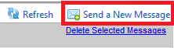

- In the window that pops up where you can type your message, click the paper clip icon located on the far right of the “Subject” text box to bring up the file selection window
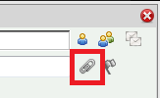

- Once the file selection window pops up, click the “Browse” button to browse your computer for the file you wish to attach to the message
  - Files to be uploaded cannot exceed 30MB
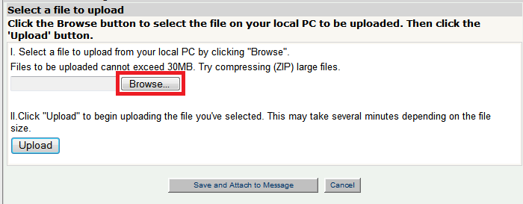

- After you have selected the file and clicked “Open”, you will need to click “Upload” to upload the file
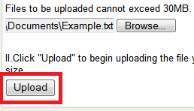
- Then click “Save and Attach to Message” to finish attaching the file
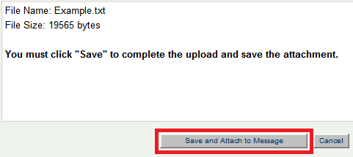
- Once attached, if you need to remove the attachment, click the blue X next to the attached file
